Package Report
Business Object Model

Issue 1.0
Revision History
Date | Issue | Description | Author
22 July 2004 | 1.0 | First Issue | Howard Russon

Table of Contents
1. Brief Description 4
2. Global Diagrams 4
2.1 Global Domain Class Diagram 4
3. Object Summary 5
3.1 Cash Store 5
3.2 Coin 5
3.3 Configuration Information 5
3.4 Customer Panel 5
3.5 Door 6
3.6 Drinks Brand 6
3.7 Drinks Store 6
3.8 Input Store 7
3.9 Machinery Simulator Panel 7
3.10 Maintenance Panel 8
3.11 Simulator Control Panel 8

Package Report
Business Object Model

Brief Description

In general, the Business Object Model contains a set of interacting workers and business entity (domain) classes that collaborate to enact the business processes. In some cases, only the business entity classes are documented. The business entity classes as a whole are sometimes referred to as a 'domain model'.

The Business Object Model for the VMCS is presented in the following sections in terms of a global class diagram and a summary of the objects.

Global Diagrams

Global Domain Class Diagram
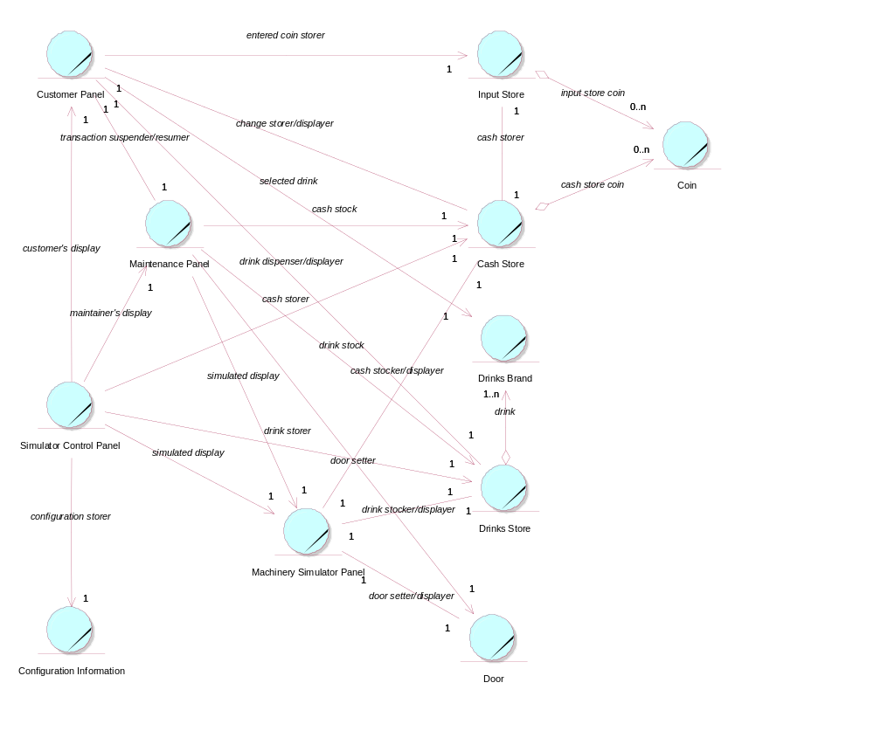

Object Summary

Cash Store
This is the repository for all Coins entered into the system. It is also where all change given to the Customer is taken from.
Relationships
Relationship Name: cash store coin::<unnamed>
Object Name: Coin
Kind of Relationship: AggregateRelationship

Relationship Name: change storer/displayer::<unnamed>
Object Name: Customer Panel
Kind of Relationship: AssociationRole

Relationship Name: cash stock::<unnamed>
Object Name: Maintenance Panel
Kind of Relationship: AssociationRole

Relationship Name: cash stocker/displayer::<unnamed>
Object Name: Machinery Simulator Panel
Kind of Relationship: AssociationRole

Relationship Name: cash storer::<unnamed>
Object Name: Input Store
Kind of Relationship: AssociationRole

Relationship Name: cash storer::<unnamed>
Object Name: Simulator Control Panel
Kind of Relationship: AssociationRole

Coin
The object stores the characteristics of coins entered into the system.

Configuration Information
This is information defining the basic details concerning the drinks brands and coins, that is read-in from file and used to initialise the simulation.
Relationships
Relationship Name: configuration storer::<unnamed>
Object Name: Simulator Control Panel
Kind of Relationship: AssociationRole

Customer Panel
This panel simulates the vending machine's customer interface panel. It will enable the user (the Customer) to:
1 insert coins;
2 select brands;
3 terminate transaction.
It will also provide the following display functions:
1 display total money inserted;
2 indicate coin not valid;
3 indicate no change available;
4 display the value of the change to be collected;
5 display an icon representing the dispensed drink.

Relationships
Relationship Name: entered coin storer::<unnamed>
Object Name: Input Store
Kind of Relationship: AssociationRole

Relationship Name: change storer/displayer::<unnamed>
Object Name: Cash Store
Kind of Relationship: AssociationRole

Relationship Name: drink dispenser/displayer::<unnamed>
Object Name: Drinks Store
Kind of Relationship: AssociationRole

Relationship Name: selected drink::<unnamed>
Object Name: Drinks Brand
Kind of Relationship: AssociationRole

Relationship Name: transaction suspender/resumer::<unnamed>
Object Name: Maintenance Panel
Kind of Relationship: AssociationRole

Relationship Name: customer's display::<unnamed>
Object Name: Simulator Control Panel
Kind of Relationship: AssociationRole

Door
This is the door of the vending machine. This is opened so that the Maintainer can re-stock the machine.
Relationships
Relationship Name: door setter::<unnamed>
Object Name: Maintenance Panel
Kind of Relationship: AssociationRole

Relationship Name: door setter/displayer::<unnamed>
Object Name: Machinery Simulator Panel
Kind of Relationship: AssociationRole

Drinks Brand
This object stores the characteristics of the types of drinks can held in the system.
Relationships
Relationship Name: selected drink::<unnamed>
Object Name: Customer Panel
Kind of Relationship: AssociationRole

Drinks Store
This is the repository for the drinks cans held by the system.
Relationships
Relationship Name: drink storer::<unnamed>
Object Name: Simulator Control Panel
Kind of Relationship: AssociationRole

Relationship Name: drink::<unnamed>
Object Name: Drinks Brand
Kind of Relationship: AggregateRelationship

Relationship Name: drink dispenser/displayer::<unnamed>
Object Name: Customer Panel
Kind of Relationship: AssociationRole

Relationship Name: drink stock::<unnamed>
Object Name: Maintenance Panel
Kind of Relationship: AssociationRole

Relationship Name: drink stocker/displayer::<unnamed>
Object Name: Machinery Simulator Panel
Kind of Relationship: AssociationRole

Input Store
When Coins are entered into the Customer Panel, they are initially held in this store until the correct amount of money has been entetred by the Customer.
Relationships
Relationship Name: input store coin::<unnamed>
Object Name: Coin
Kind of Relationship: AggregateRelationship

Relationship Name: entered coin storer::theInput Store
Object Name: Customer Panel
Kind of Relationship: AssociationRole

Relationship Name: cash storer::<unnamed>
Object Name: Cash Store
Kind of Relationship: AssociationRole

Machinery Simulator Panel
This panel simulates the physical actions of the maintainer. It enables the user to:
1 display and enter new values for the number of cans of each Drinks Brand held by the Drinks Store;
2 display and enter new values for the number of Coins of each denomination held by the Cash Store;
3 display whether the vending machine Door is unlocked, and enable it to be locked.

Relationships
Relationship Name: simulated display::<unnamed>
Object Name: Maintenance Panel
Kind of Relationship: AssociationRole

Relationship Name: cash stocker/displayer::<unnamed>
Object Name: Cash Store
Kind of Relationship: AssociationRole

Relationship Name: drink stocker/displayer::<unnamed>
Object Name: Drinks Store
Kind of Relationship: AssociationRole

Relationship Name: door setter/displayer::<unnamed>
Object Name: Door
Kind of Relationship: AssociationRole

Relationship Name: simulated display::<unnamed>
Object Name: Simulator Control Panel
Kind of Relationship: AssociationRole

Maintenance Panel
This panel simulates the vending machines maintainer control panel. It will enable the user (the Maintainer) to:
1 log-on using a password;
2 display number of Coins of each denomination in the Cash Store;
3 display total value of cash in the system;
4 display number cans of each Drinks Brand held in the Drinks Store;
5 change the price of any Drinks Brand;
6 collect all cash held in system;
7 formally exit from the panel.

Relationships
Relationship Name: simulated display::<unnamed>
Object Name: Machinery Simulator Panel
Kind of Relationship: AssociationRole

Relationship Name: cash stock::<unnamed>
Object Name: Cash Store
Kind of Relationship: AssociationRole

Relationship Name: drink stock::<unnamed>
Object Name: Drinks Store
Kind of Relationship: AssociationRole

Relationship Name: door setter::<unnamed>
Object Name: Door
Kind of Relationship: AssociationRole

Relationship Name: transaction suspender/resumer::<unnamed>
Object Name: Customer Panel
Kind of Relationship: AssociationRole

Relationship Name: maintainer's display::<unnamed>
Object Name: Simulator Control Panel
Kind of Relationship: AssociationRole

Simulator Control Panel
This panel is displayed when the system is started up. It enables the user (the Controller) to :
1 start (switch on);
2 stop (switch off);
3 activate the customer panel;
4 activiate the maintenance panel;
5 activate the machinery simulator panel.

Relationships

Relationship Name: drink storer::<unnamed>
Object Name: Drinks Store
Kind of Relationship: AssociationRole

Relationship Name: configuration storer::<unnamed>
Object Name: Configuration Information
Kind of Relationship: AssociationRole

Relationship Name: maintainer's display::<unnamed>
Object Name: Maintenance Panel
Kind of Relationship: AssociationRole

Relationship Name: customer's display::<unnamed>
Object Name: Customer Panel
Kind of Relationship: AssociationRole

Relationship Name: simulated display::<unnamed>
Object Name: Machinery Simulator Panel
Kind of Relationship: AssociationRole

Relationship Name: cash storer::<unnamed>
Object Name: Cash Store
Kind of Relationship: AssociationRole

